Integrating Maven with Jenkins

Step 1: Install the Maven plugin

- Click on the Manage Jenkins option as shown in the screenshot below → Click on the Plugins option as shown in the screenshot below → Click on Installed plugins to verify whether the Maven Integration plugin has been installed

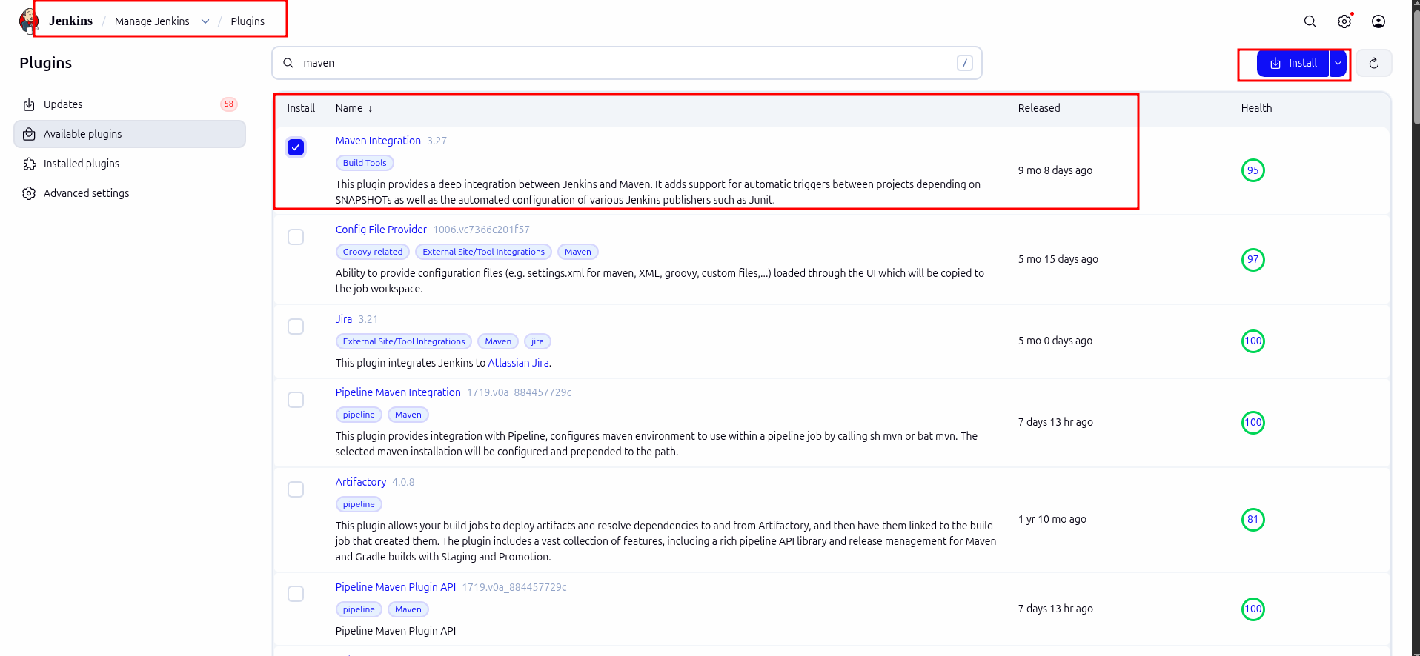

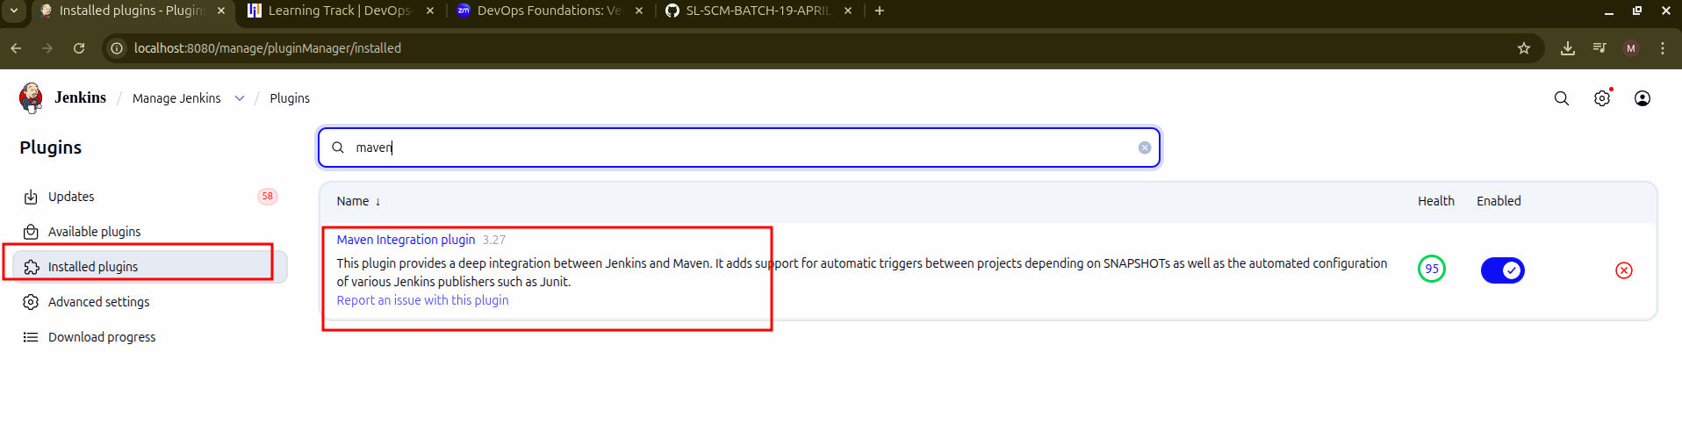

- Use the following command to check the Maven version:
mvn -version

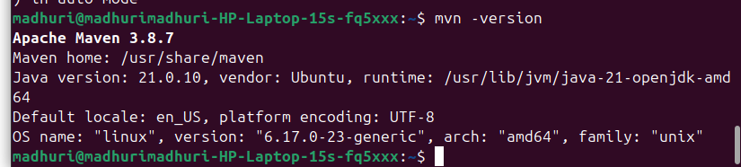

Step 2: Set up Global Tool Configuration

- Go to the Jenkins Dashboard, click on Manage Jenkins, and then select Tools from the list of options

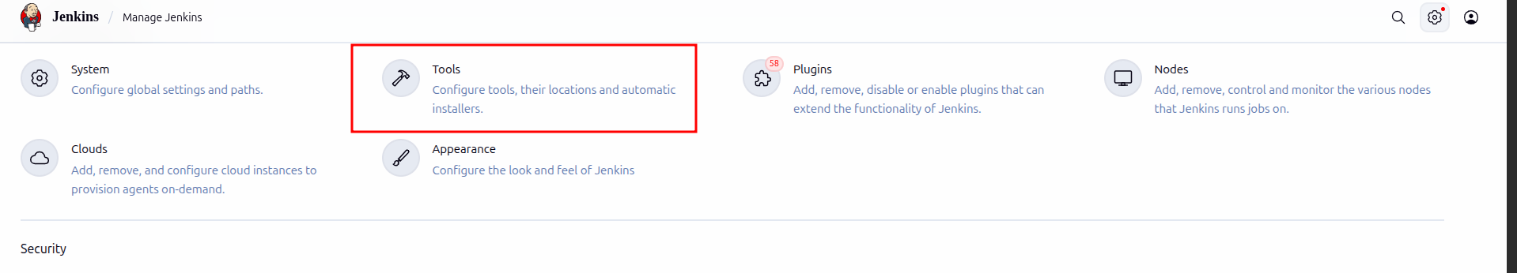

- Click on JDK installations and provide the Name and JAVA_HOME path
Note: Set the JAVA_HOME environment variable to /usr/lib/jvm/java-11-openjdk-amd64
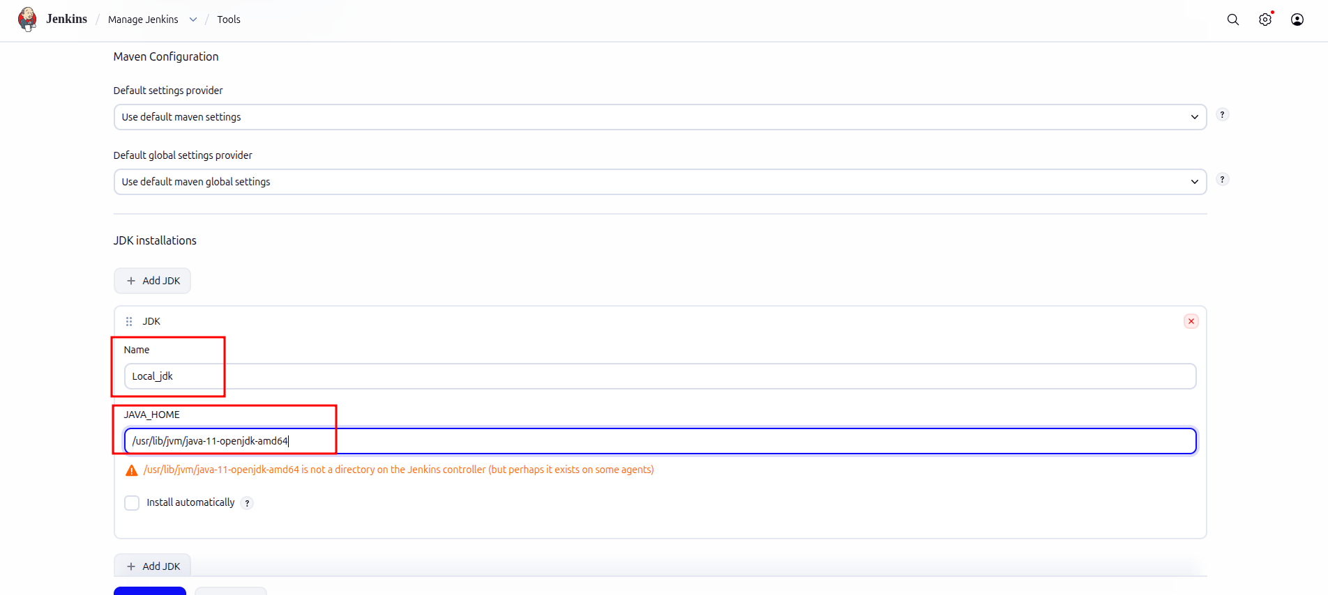

- To configure Maven, click on the Maven installations button in the Maven section and enter a Name and MAVEN_HOME path
Note: Set the MAVEN_HOME environment variable to /usr/share/maven
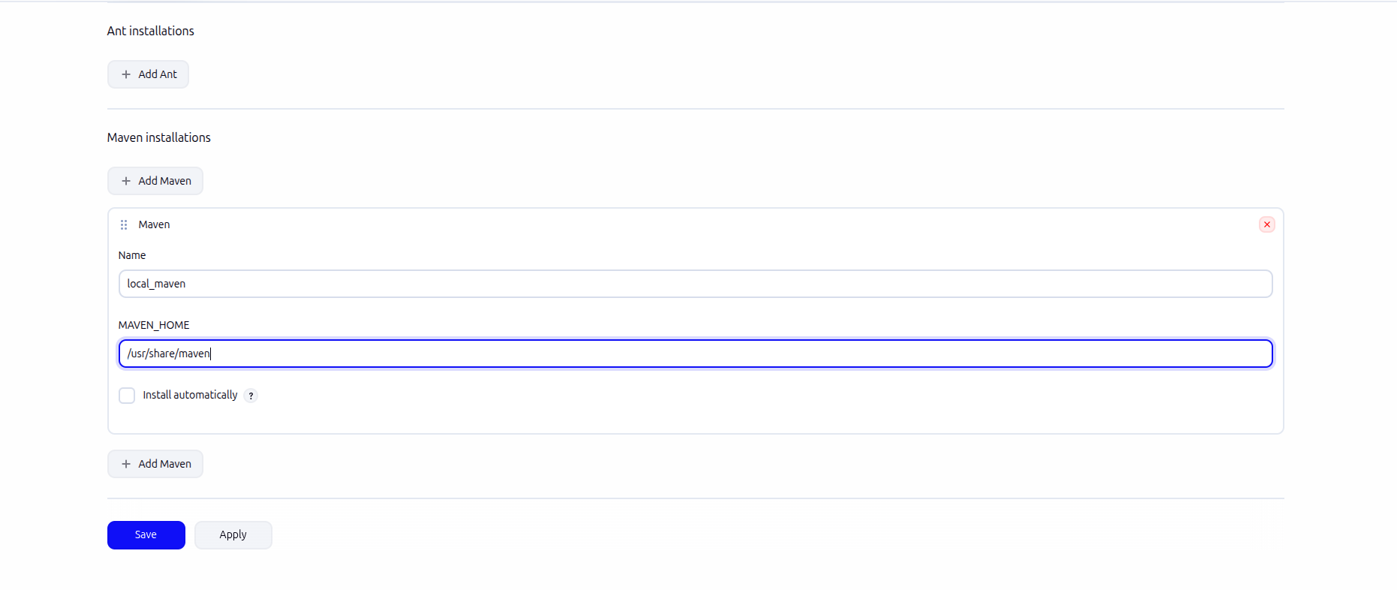

- To configure Git, click on Git installations and add the Name and Path to Git executable

Note: Set the Path to Git executable environment variable to /bin/git and click on Save

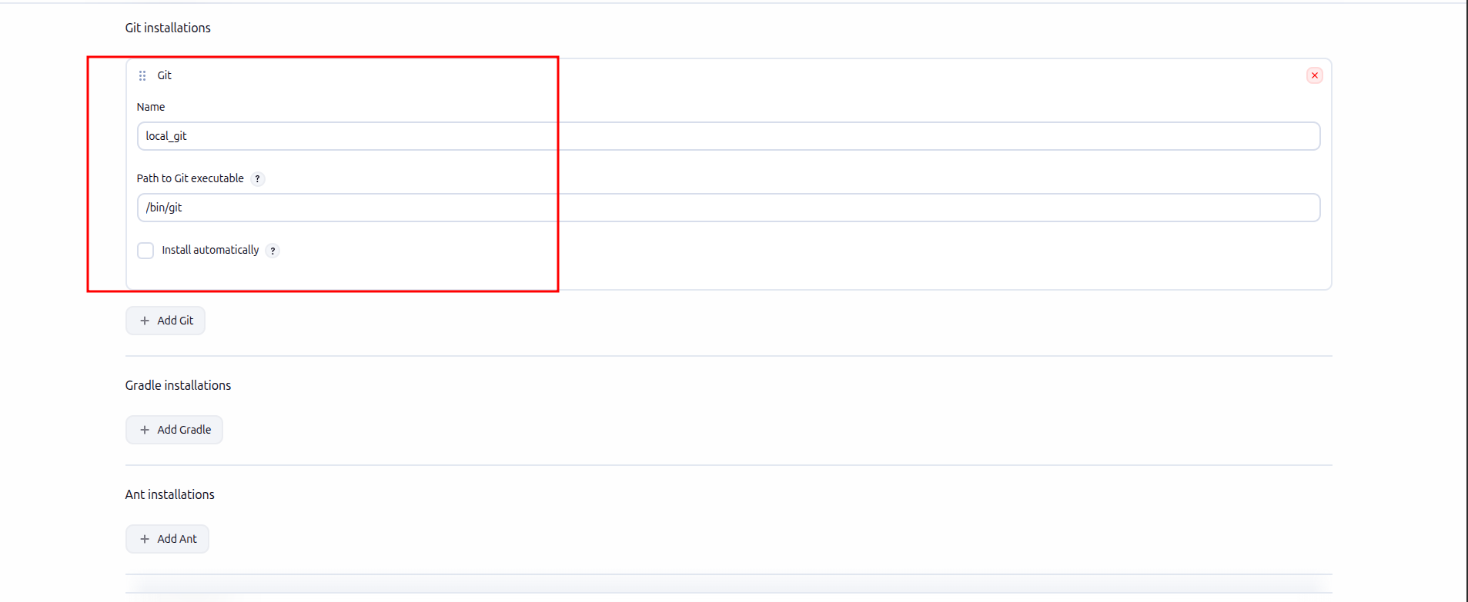

Step 3: Fork a sample repository

- Log in to your GitHub account, navigate to https://github.com/jenkins-docs/simple-java-maven-app, and click on Fork

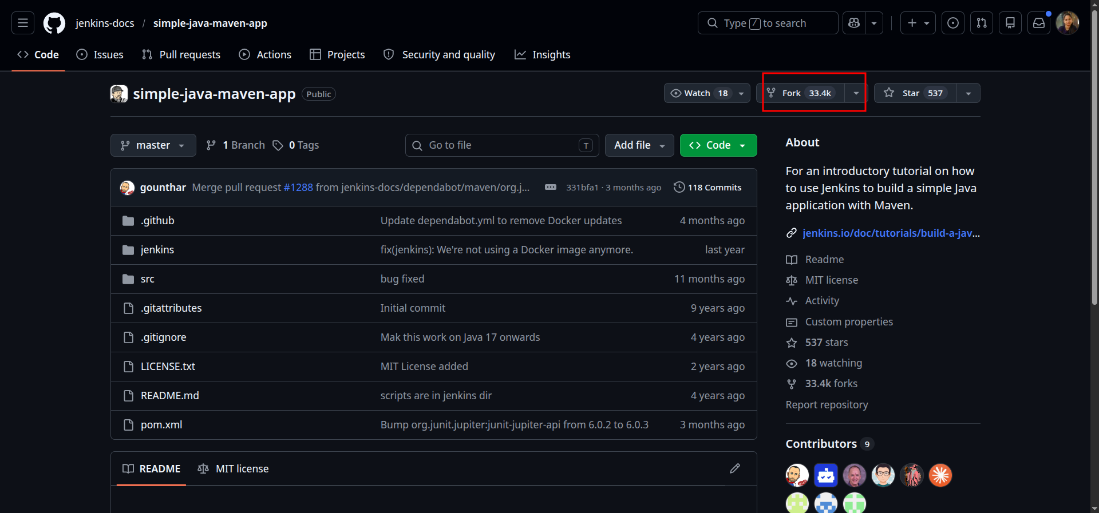

- Run git clone [Forked REPO URL] in the terminal to clone the repository locally

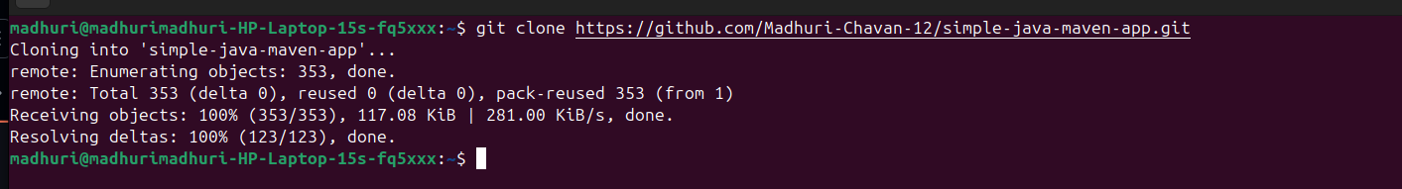

Step 4: Integrate Maven with Jenkins

- Click on New Item in the Jenkins Dashboard → Enter a name for the project, select Freestyle project as the build job type, and click on the OK button as shown in the screenshot below:

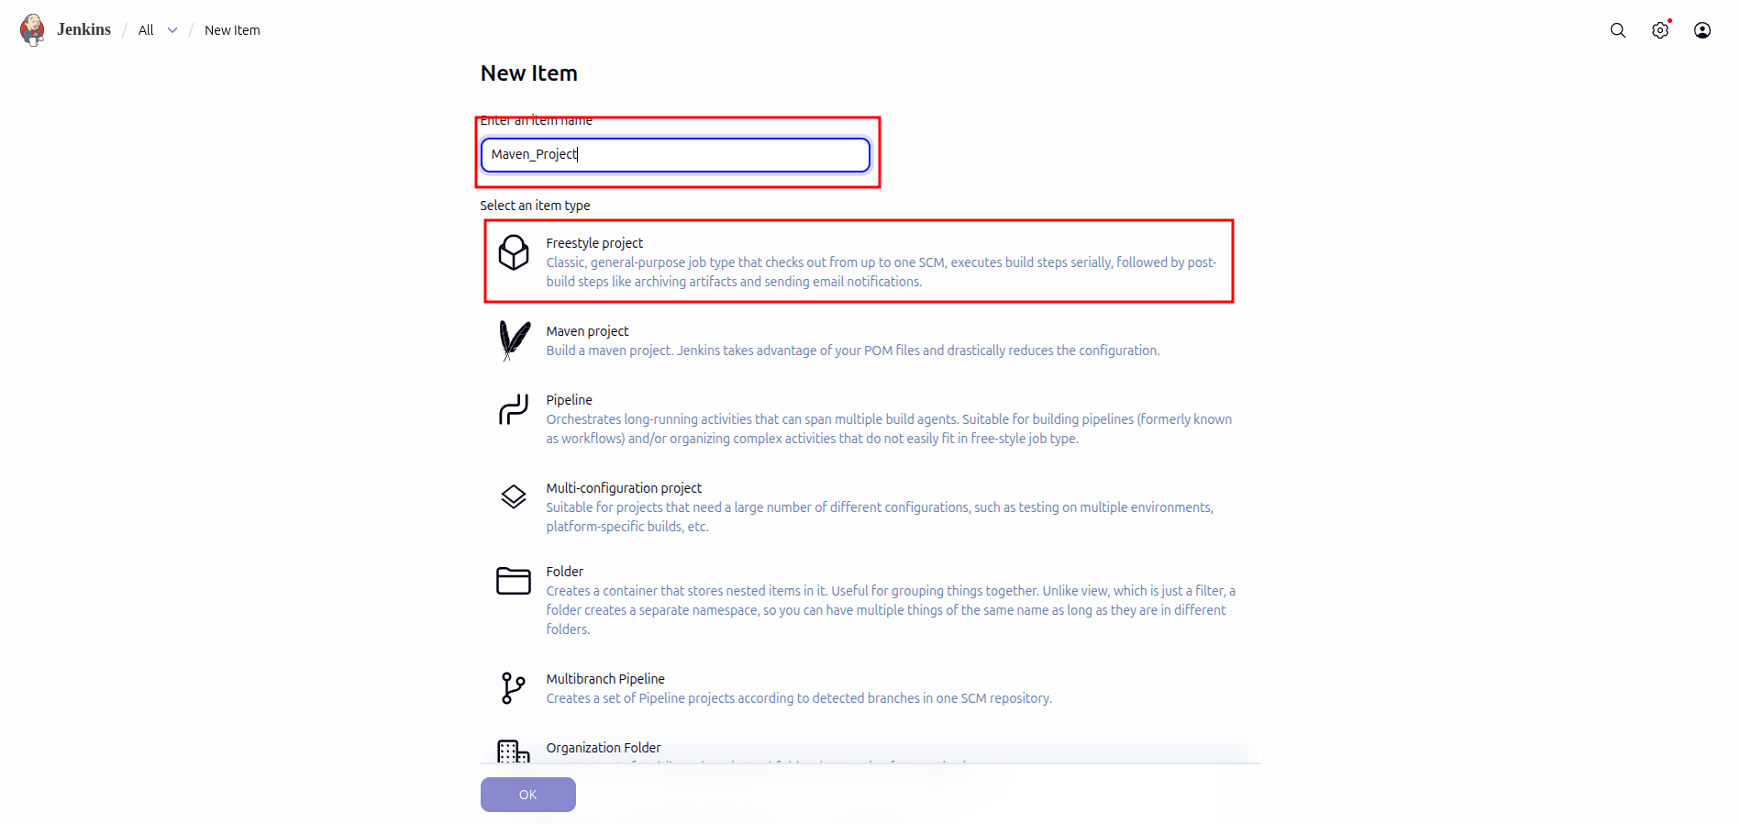

- Click on Source Code Management → Select Git and enter the Repository URL

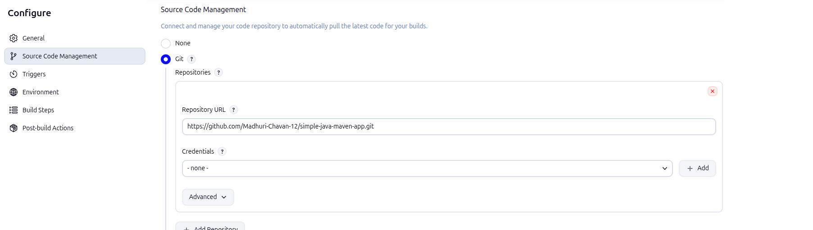

- Click on Build Triggers, select the required option as shown in the screenshot below, and then click on Save
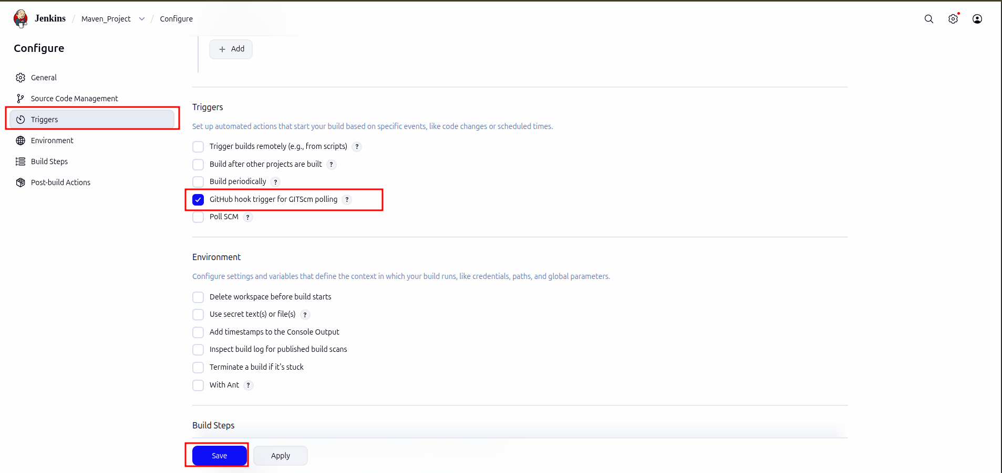

- Click on Build Now to view the build results

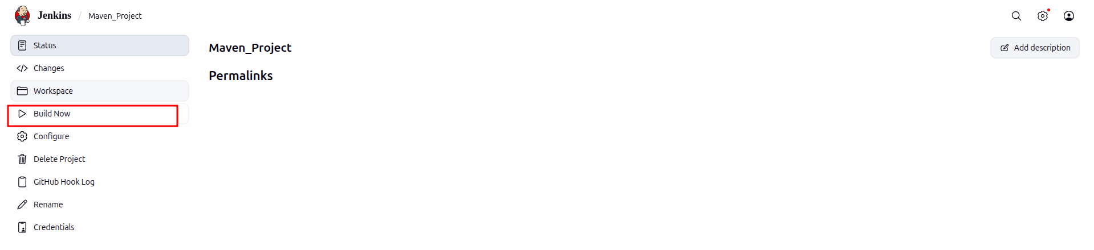

- Click on Status to view the build logs

